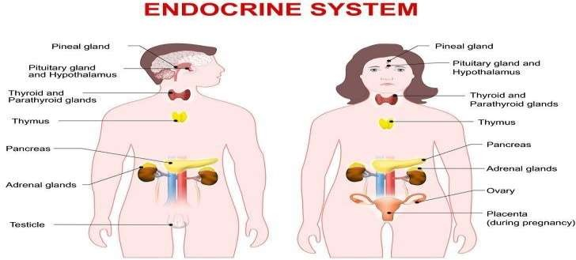

INTRODUCTION;
Your endocrine system is made up of several organs called glands. These glands, located all over your body, create and secrete (release) hormones.

Hormones are chemicals that coordinate different functions in your body by carrying messages through your blood to your organs, skin, muscles and other tissues. These signals tell your body what to do and when to do it.

ANATOMY
The endocrine system is made up of organs called glands. Glands produce
and release different hormones that target specific things in the body. You have glands all over your body, including in your neck, brain and reproductive organs. Some glands are tiny, about the size of a grain of



rice or a pea. The largest gland is the pancreas, which is about 6 inches
long.

The main glands that produce hormones include:
- Hypothalamus: This gland is located in your brain and controls your endocrine system. It uses information from your nervous system to determine when to tell other glands, including the pituitary gland, to produce hormones. The hypothalamus controls many processes in your body, including your mood, hunger and thirst, sleep patterns and sexual function.
- Pituitary: This little gland is only about the size of a pea, but it has a big job. It makes hormones that control several other glands such as the thyroid gland, adrenal glands, ovaries and testicles. The pituitary gland is in charge of many different functions, including how your body grows. It’s located at the base of your brain.
- Thyroid: Your thyroid is a butterfly-shaped gland in the front of your neck. It’s responsible for your metabolism (how your body uses energy).
- Parathyroid: These four tiny glands are no larger than a grain of rice. They control the level of calcium in your body. For your heart, kidneys, bones and nervous system to work, you need the right amount of calcium.
- Adrenal: You have two adrenal glands, one on top of each kidney. They control your metabolism, blood pressure, sexual development and response to stress.
- Pineal: This gland manages your sleep cycle by releasing melatonin, a hormone that causes you to feel sleepy.
- Pancreas: Your pancreas is part of your endocrine system, and it plays a significant role in your digestive system too. It makes a hormone called insulin that controls the level of sugar in your blood.
- Ovaries: In women, the ovaries release sex hormones called estrogen, progesterone and testosterone. Women have two ovaries in their lower abdomen, one on either side.
- Testes: In men, the testes (testicles) make sperm and release the hormone testosterone. This hormone affects sperm production, muscle strength and sex drive.

FUNCTION.

Your endocrine system continuously monitors the amount of hormones in your blood. Hormones deliver their messages by locking into the cells they target so they can relay the message.

The pituitary gland senses when your hormone levels rise, and tells other glands to stop producing and releasing hormones. When hormone levels dip below a certain point, the pituitary gland can instruct other glands to produce and release more. This process, called homeostasis, works similarly to the thermostat in your house. Hormones affect nearly every process in your body, including:

- Metabolism (the way you break down food and get energy from nutrients).
- Growth and development.
- Emotions and mood.
- sexual function.
- Sleep.
- Blood pressure.
Sometimes glands produce too much or not enough of a hormone. This imbalance can cause health problems, such as weight gain, high blood pressure and changes in sleep, mood and behavior.
Many things can affect how your body creates and releases hormones. Illness, stress and certain medications can cause a hormone imbalance

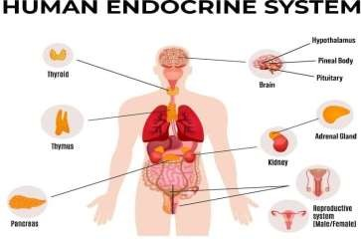

CONDITIONS AND DISORDERS
Dozens of conditions can cause issues in the endocrine system. These conditions can lead to health problems all over the body. Some of the most common disorders are:

- Diabetes: This endocrine disorder affects the way your body uses the energy from the food you eat. Diabetes develops when the pancreas doesn’t make enough of a hormone called insulin, or insulin doesn’t work as it should.
- Thyroid disorders: Several conditions can affect the function of the
thyroid gland. Hypothyroidism happens when the thyroid doesn’t produce enough hormones. Hyperthyroidism occurs when it creates too many hormones.
- Hypogonadism (low testosterone): In men, hypogonadism can cause erectile dysfunction. It can also cause memory and concentration problems, changes in muscle strength and low sex drive. It happens when the testes do not produce enough of the sex hormone testosterone.
- Polycystic ovary syndrome (PCOS): A hormonal imbalance causes women with PCOS to have irregular periods, abnormal hair growth, excess acne and weight gain. It can lead to diabetes, increased risk of metabolic syndrome and infertility.
- Osteoporosis: When a woman’s ovaries don’t produce enough estrogen, bones become brittle and weak. Although it is more common in women, men sometimes have osteoporosis when testosterone levels get too low. People with an overactive parathyroid gland (hyperparathyroidism) may also have weak bones.

Chemicals called endocrine disrupters can also affect the endocrine system. These chemicals appear everywhere — in pesticides, plastics, cosmetics and even our food and water. Endocrine disrupters cause a wide range of problems throughout the body by changing how hormones send messages.
Diabetes: This condition is widespread. Almost 10% of people in the
United States have diabetes and 27% have prediabetes.

- Thyroid disorders: About 20 million Americans have thyroid disease. Women are about five times more likely than men to develop the condition.
- Hypogonadism: About 40% of men over 45 have low testosterone. Levels of this sex hormone naturally drop as men age. Other factors, such as a man’s diet, weight and other health problems also affect testosterone levels.
- Osteoporosis: More than half of adults over age 50 have
osteoporosis. It is more likely to occur in women than in men.

Medical Terminology of the Endocrine System
Endocrine system | Endo means within or inward.
 | Crine means endocrine secretion.
 | The endocrine system consists of a series of organs and glands throughout the body that produce, store, and secrete special chemical messengers.
Gland | Glands are where hormones are produced and secreted into the bloodstream.

Endocrinology | Endo means within or inward.
 | Crine means endocrine secretion.
 | -ology is the study of.
 | Endocrinology is a medical specialty that treats conditions related to the endocrine system.
Endocrinologist | Endo means within or inward.
 | Crine means endocrine secretion.
 | -logist means one who studies.
 | An endocrinologist is a person who treats conditions related to the endocrine system.

